Math Semaine 9
Math Puzzles & Brain Teasers
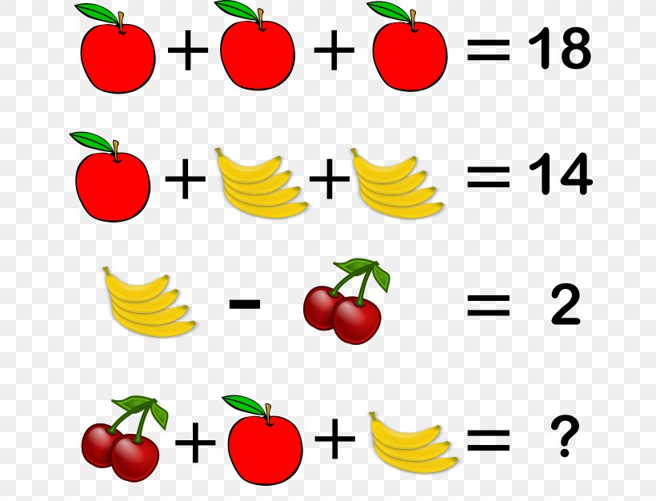
A) 1 apple = ________
1 banana = ________
1 cherry = ________
Answer = ________

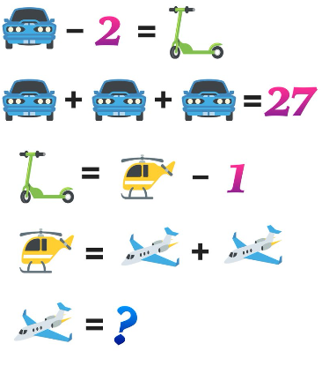
B) 1 Car = ________
1 Scooter = ________
1 Helicopter = ________
Airplane = ________

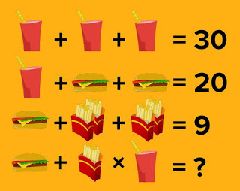
C) 1 Drink = ________
1 Hamburger = ________
1 Fries = ________
Answer = ________

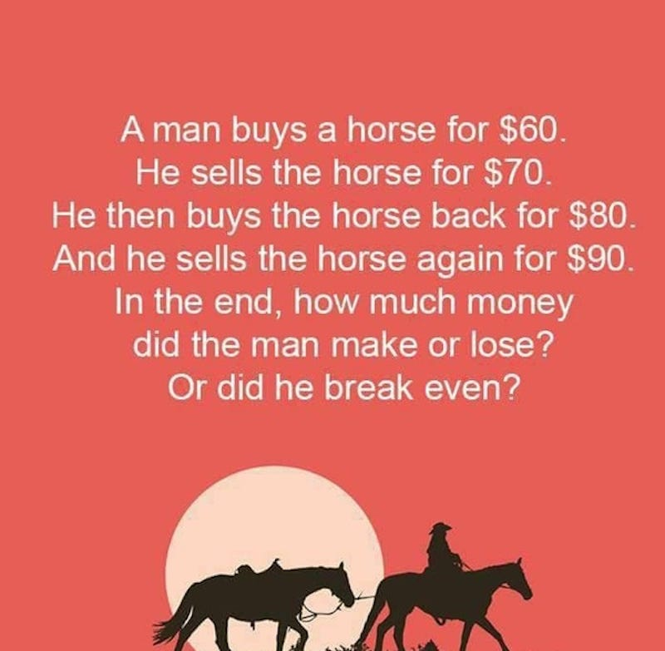
D) Answer: _____________________

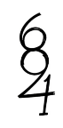
E) List all the digits that you can see in this image:

F) Look for the pattern. What is the value of the ?? in the 4th image? ________
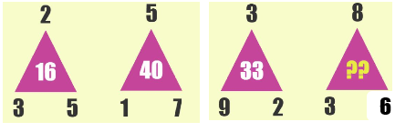

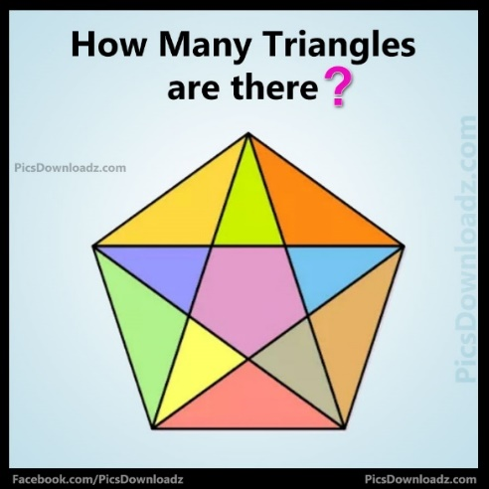
G) Answer: ________

